**Deliverable 2 - Report**

For our second deliverable we have the goal to show our progress (compared to deliverable 1) and what features we are working on. We will provide insights about the key features we have successfully implemented and the features we are working on. Our focus areas for this deliverable include:

* **AWS server**
* **Test cases**
* **Api documentation**
* **CD/CI**

We believe we will be ending the project soon being able to apply all the tools/methods learned in class.

## AWS Infrastructure

In Deliverable 2, we have made significant progress in setting up and optimizing our AWS infrastructure/server. We successfully configured AWS services to host and manage our web services. Our website can be found with the following IP address: [*http://13.58.235.73/*](http://13.58.235.73/).

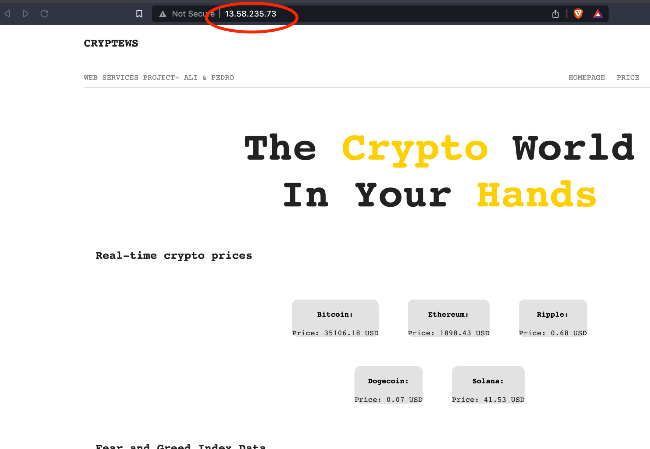

We are glad we were able to store our website on the aws server which means it is visible for the “world”.

## Test Cases

In our API development process, we prioritize the validation of important parameters such as the name of Cryptos, the Symbol of each type of cryptocurrency, API-key, price of the cryptocurrency, and the market capacity for each crypto. It's essential to make sure that these parameters are not null, and to verify the correct type of price. Errors with this features can lead the users to false information which can have a bad impact on these same users finances/investments. To address this, we've added an "app.test.js" file to our repository (image below):

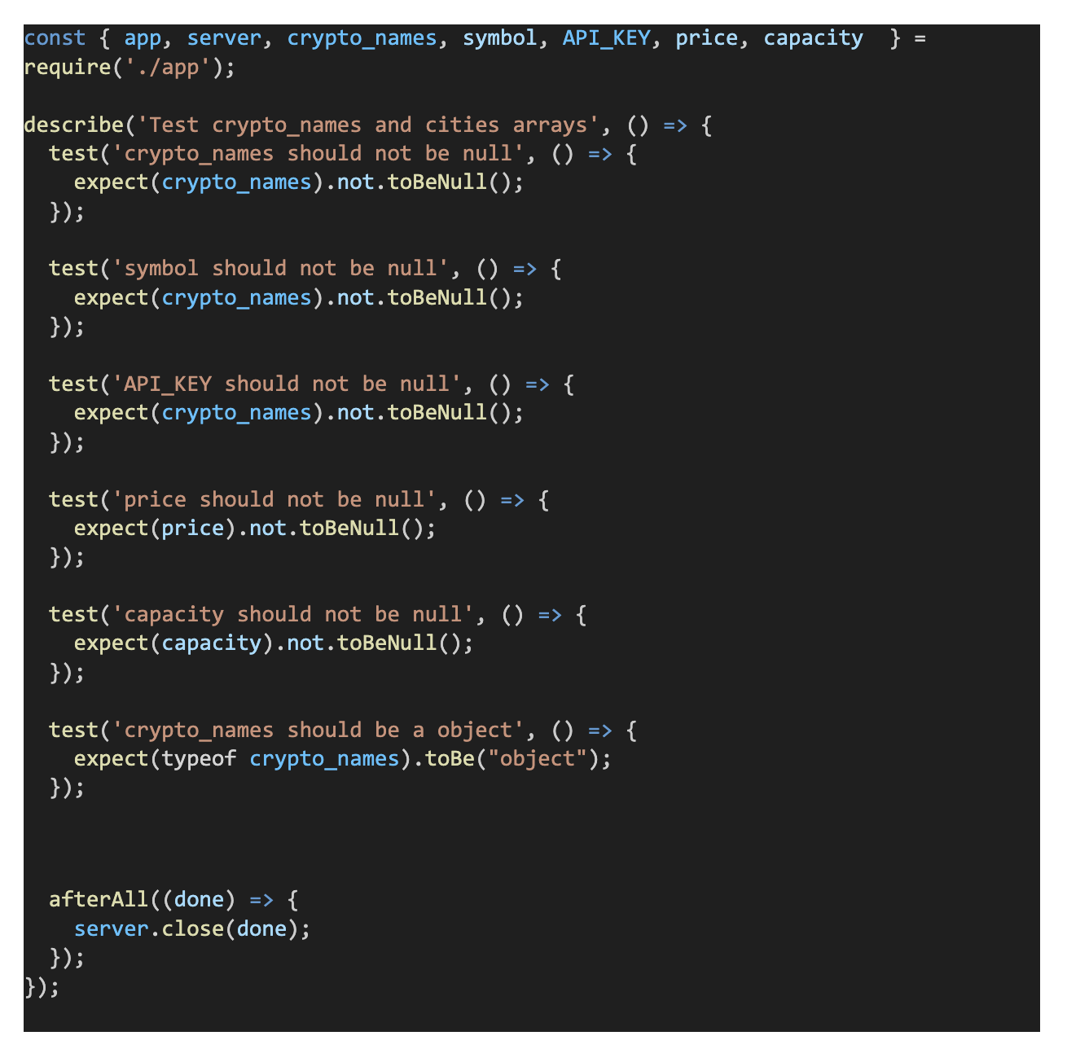

After executing this JS code, we will have:

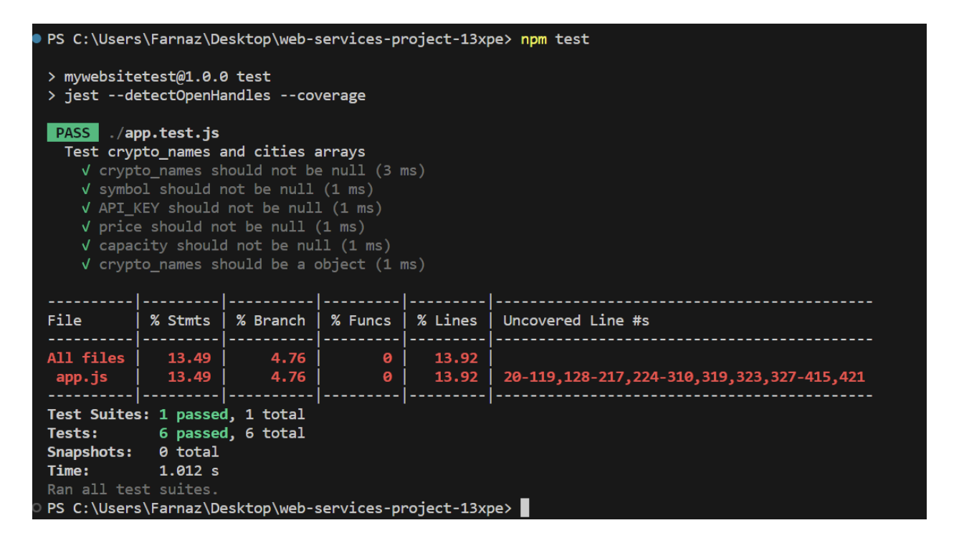

As said above we have established a group of test cases that checks the reliability and functionality of our website/platform. These tests mean various topics, including API testing, checking our converter feature, and performance testing. This testing methodology guarantees that our website performs optimally under different conditions.

## Continuous Integration and Continuous Delivery (CI/CD)

Our team is currently in the process of implementing CI/CD tools to automate our deployment procedures. This initiative is ongoing, and we intend to showcase the results in our final presentation.

Once we implement CI/CD tools, we predict to have updates, minimize downtime, and integrate new features to our website. We anticipate that this automation will maintain a consistent and efficient development and deployment project, helping our workflow.

## API Documentation

We understand the importance of clear and accessible API documentation. Our team has diligently worked on creating user-friendly documentation for the APIs we've chosen. This documentation provides developers and users with comprehensive information on the endpoints, request and response formats, authentication, and usage examples.

We are still working on this documentation as we want to make sure that it is clear and user friendly.